Title of the paper (Style: Title)
Name of author 1 ⁽¹⁾, Name of author 2 ⁽²⁾, Name of author n ^{(n)} (Style: ICAAR_author)
(1) Affiliation, City, Country, email (Style: ICAAR_infoauthor)
(2) Affiliation, City, Country, email (Style: ICAAR_infoauthor)
(n) Affiliation, City, Country, email (Style: ICAAR_infoauthor)
Abstract
Write your Abstract text here with a maximum length of 20 lines or 1500 characters (Style: ICAAR_summary).
Keywords: maximum of five; in alphabetical order; lowercase letter, italic (Style: ICAAR_keywords)

ATTENTION: please read carefully the following instructions, print them for later consult and erase them in this document from this paragraph onwards. The text above will be the template for your text. Write over it.

Chapter (Style: 1. Heading 1)
Write your text here

Sub-chapter level 1 (Style: 1.1 Heading 2)
Write your text here

Sub-chapter level 2 (Style: 1.1.1 Heading 3)
Write your text here

These instructions explain how you should write your paper in order to submit it in digital format to the 16th International Conference on Alkali-Aggregate Reaction in Concrete – ICAAR 2020-2022. It is important to respect these instructions in order to have your paper printed in the Conference proceedings.
For your commodity, please use the first page above as the layout of your paper. It contains the basic format and styles definitions to be followed.

rules and recommendations
The maximum length of the paper is 12 pages.
The written area should be 160x252 mm which is the size used here for these instructions. Only the authorized font can be used.

Fonts
Authorized font is Arial (title, chapters, sub-chapters and body text). Only the equations can be written using the Cambria Math font.
The text styles are already defined in the present template. Please do not modify them in your document.
The template includes everything that you will need. However, please note the styles as follows:

Title | Arial | 14pt | Bold | Style for the paper title
ICAAR_author | Arial | 11pt | Bold | Style for the name(s) of the author(s)
ICAAR_infoauthor | Arial | 10pt | Italic | Style for the information relative to the authors
ICAAR_keywords | Arial | 10pt | Normal | Style for the keywords
Heading 1 | Arial | 13pt | Bold | Style for the chapters titles
Heading 2 | Arial | 12pt | Bold | Style for the sub-chapter level 1
Heading 3 | Arial | 10pt | Bold | Style for the sub-chapter level 2
Normal | Arial | 10pt | Normal | General style for text
ICAAR_references | Arial | 10pt | Normal | General style for references
Caption Figure | Arial | 10pt | Normal | General style for figures
Caption Table | Arial | 10pt | Normal | General style for tables
Equations | Cambria Math | 10pt | Normal | General style for equations

In case you need special styling options (e.g. spot underlining, bold, italics, etc.) please format them directly on the text. Do not create new styles, since they cannot be kept in the final printing.

Citations
Citations should be used in the text. Footnotes are not permitted. All the references should appear together in a single list at the end of the paper in the “References” section.
Citations in the text should be identified by numbers in square brackets as shown in the following examples:
Negotiation research spans many disciplines [3].
This result was later contradicted by Becker and Seligman [5].
This effect has been widely studied [1-3, 7].

Figures and tables
Figures and tables shall respect the text layout (160x252 mm) and inserted throughout the article. For pictures, please use a printing resolution (300 dpi minimum).
Figures, tables and equations should be referenced as Figure 3.1, Table 3.1 and Equation (1).
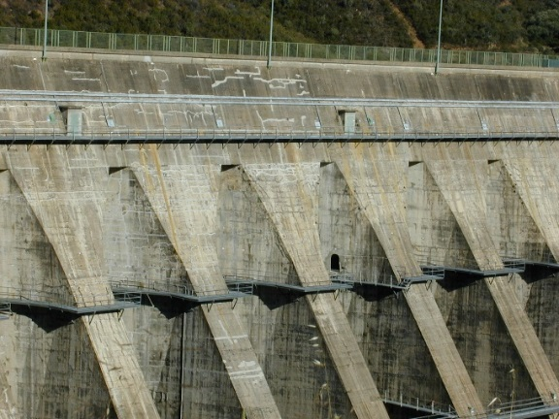
Figure 3.1: Conference announcement (Style: Caption)
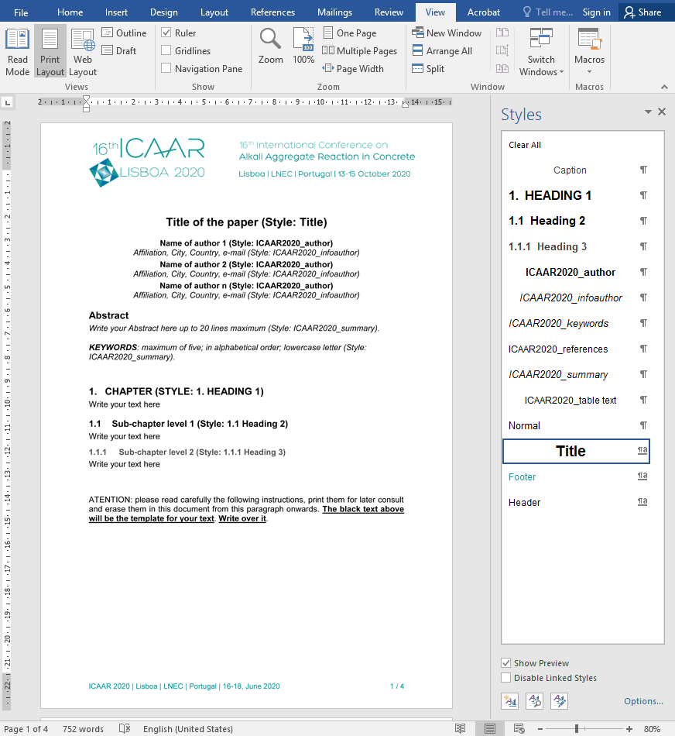
Figure 3.2: Style list (Style: Caption)
Table 3.1: Example of a table construction (Style: Caption)
Column 1 | Column 2 | Column 3
C11 | C12 | C13
C21 | C22 | C23
C31 | C32 | C33
C41 | C42 | C43
C51 | C52 | C53

Equations should be inserted into invisible tables, as shown below. Equations style is Cambria Math 10pt.
$${\left(1+x\right)}^{n}=1+\frac{nx}{1!}+\frac{n\left(n-1\right)x^{2}}{2!}+…$$ | (1)
$$\sin{α}±\sin{β}=2\sin{\frac{1}{2}\left(α±β\right)}\cos{\frac{1}{2}\left(α∓β\right)}$$ | (2)

References
References list follows the style used in the journal “Materials and Structures”.
The References list should only include works that are cited in the text and that have been published or accepted for publication. Personal communications and unpublished works should only be mentioned in the text. Do not use footnotes or endnotes as a substitute for a reference list. The entries in the list should be numbered consecutively.
Journal article:
[1] Gamelin FX, Baquet G, Berthoin S, Thevenet D, Nourry C, Nottin S, Bosquet L (2009) Effect of high intensity intermittent training on heart rate variability in prepubescent children. Eur J Appl Physiol 105:731-738. https://doi.org/10.1007/s00421-008-0955-8
Article by DOI:
[2] Slifka MK, Whitton JL (2000) Clinical implications of dysregulated cytokine production. J Mol Med. https://doi.org/10.1007/s001090000086
Book:
[3] South J, Blass B (2001) The future of modern genomics. Blackwell, London
Book chapter:
[4] Brown B, Aaron M (2001) The politics of nature. In: Smith J (ed) The rise of modern genomics, 3rd edn. Wiley, New York, pp 230-257
Online document:
[5] Cartwright J (2007) Big stars have weather too. IOP Publishing PhysicsWeb. http://physicsweb.org/articles/news/11/6/16/1. Accessed 26 June 2007
Dissertation:
[6] Trent JW (1975) Experimental acute renal failure. Dissertation, University of California

Always use the standard abbreviation of a journal’s name according to the ISSN List of Title Word Abbreviations, see: http://www.issn.org/services/online-services/access-to-the-ltwa/
If you are unsure, please use the full journal title.

Instructions for EndNote users:
Please consider the style defined at:
http://static.springer.com/sgw/documents/943237/application/zip/SpringerBasicNumber.zip
Instructions for Mendeley users:
Please choose the “Materials and Structures” style in the menu: “View” “Citation Style” “More styles”. Then choose the “Get More Styles” tab and write “Materials and Structures”. Click in the button “Use this Style” in the right in order to select and use the style.

Submission of papers
Your revised paper should be submitted, as a Word document, before February 12, 2021.
To submit the paper, authors must access their personal area, using the EasyChair platform.

IMPORTANT:
The registration must be paid by March 17th 2021 to have papers included in the Conference proceedings.

